Lea Ford Cottage – Throwback Thursday

Lea Ford Cottage originally stood just beyond Church Pool covert and overlooked a ford across the River Tame. In August 1975 work began on dismantling the cottage, restoring & re-siting it. Skilled workers reconstructed the cottage, restoring oak timbers, infilling with wattle and daub. A thatched roof of long straw was tied to the battens below with bramble and the reconstruction
(re-erected in 1977) shows it just as it was 300 years ago when it was known as Maggots Croft. Deeds showing the sale of the cottage together with barn &
garden to Sir Charles Adderley in 1675 indicate that the cost was £20. Downstairs the cottage has a main room where the family would live, cook & eat meals, & an inner room which would have been used for storage. Upstairs were two bedrooms.
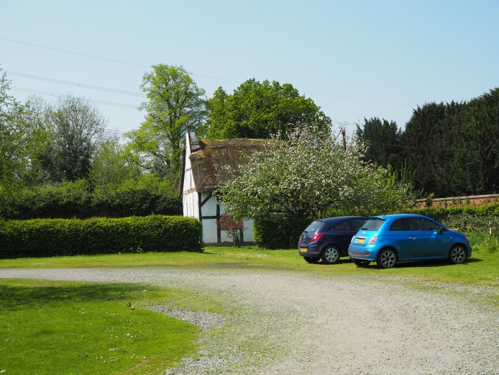
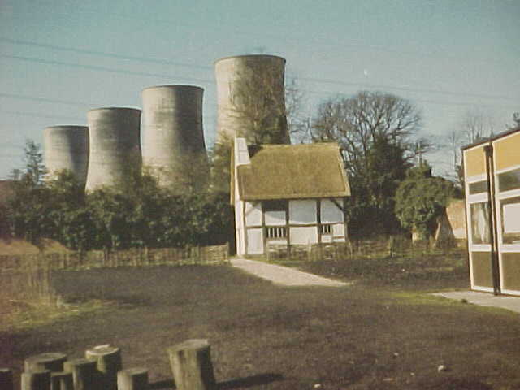
Then and Now (1980s and 2016)
Copyright. Ebony Smith.
Copyright. Martin Wheeler.
More Information
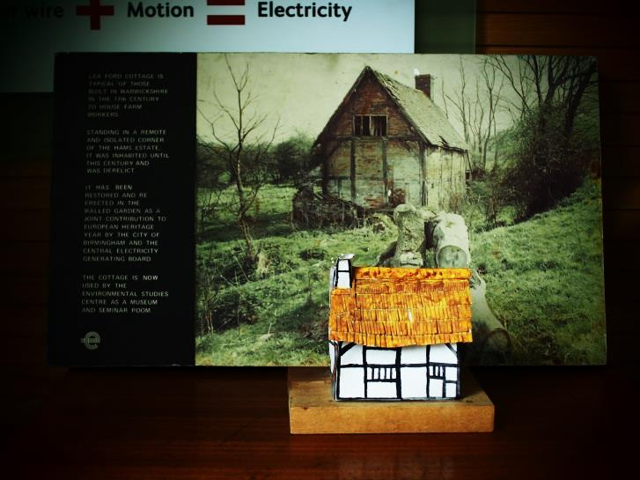
Lea Ford Cottage is typical of those built in Warwickshire in the 17th Century to house farm workers. Standing in a remote and isolated corner of the Hams Estate, it was inhabited until this century and was derelict. It has been restored and re-erected in the walled garden as a joint contribution to European heritage year by the city of Birmingham and the central electricity generating board. The cottage is now used by the Environmental Studies Centre as a museum and seminar room.
Copyright. Ebony Smith.
Copyright. Martin Wheeler.
New and old photos

1980s 2016
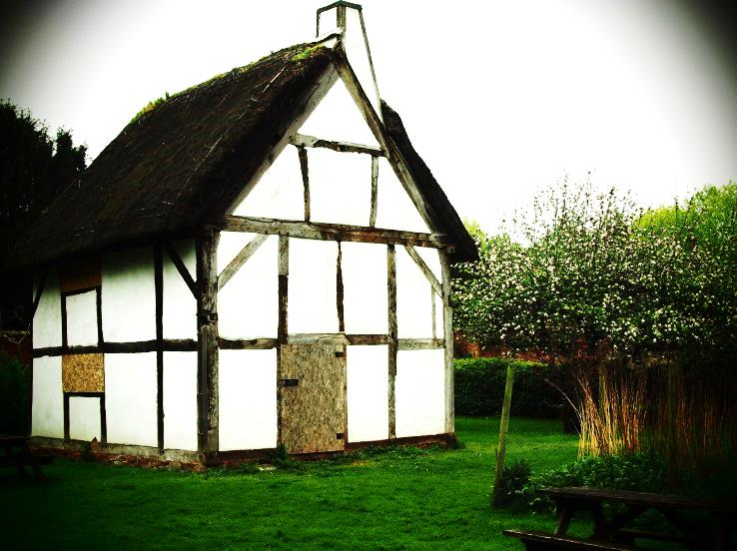
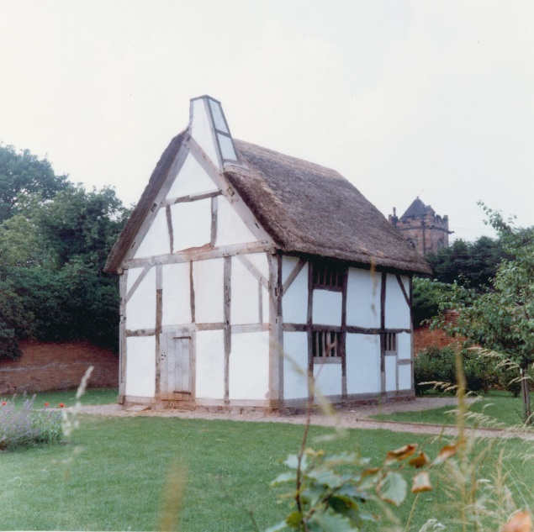
Copyright. Martin Wheeler.

Copyright. Ebony Smith.

Hand Made Model presented at Tame Valley Wetlands, Hams Hall Office.
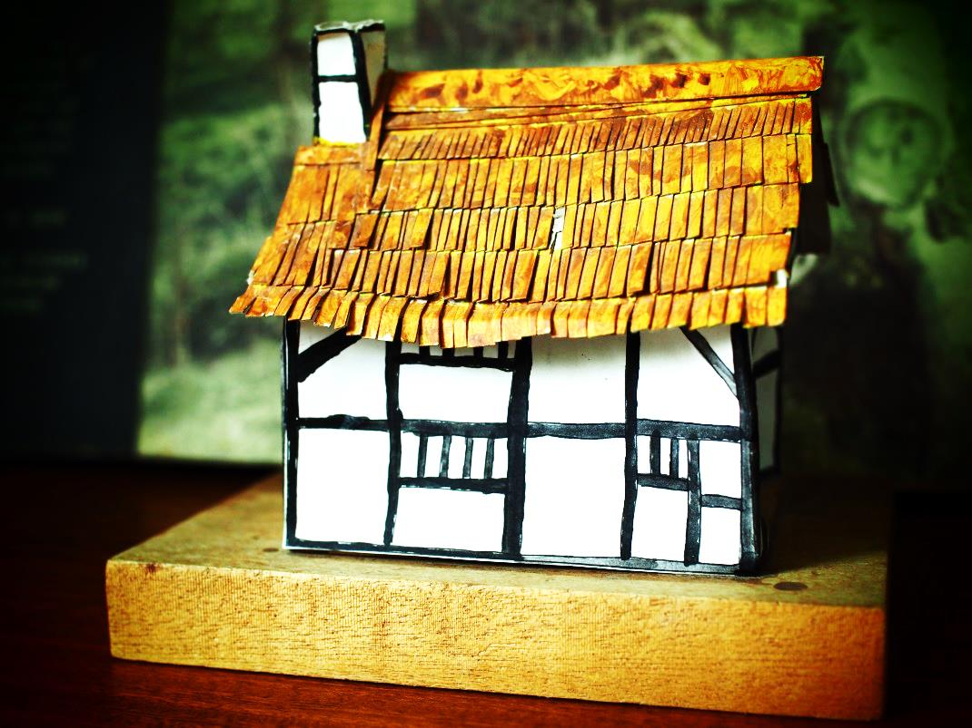

Copyright. Ebony Smith.

Reference: BBC History, Domesday. http://www.bbc.co.uk/history/domesday/dblock/GB-420000-291000/page/8# 12.05.16

